# CIS-440 Project

**1.A description of the specific process to be used, including the artifacts to be developed and the level of ceremony to be used. Provide a rationale to justify these decisions.**

One of the iterative process is Rational unified process. It is a development process that divides the process into four phases Inception, Elaboration, Construction, Transition.

**Inception phase :** you will focus on handling the risks related to the business case: Is this project financially worthy? Is it feasible? What are the resources that are needed? The Law Enforcement Information Technology Standards Council has identified the need for a national standard for computer aided dispatch (CAD).

Coming to the resources that are needed

* A baseline document is developed.
* Budget and financial.
* Develop vision
* Secure funding
* Visualize results

**Elaboration phase :**  you will focus mostly on :

* Technical risks
* Examining the architectural risks
* Revisiting the scope etc. as the requirements become better understood.

Technical risks include

* Communication between callers
* Location tracing
* Call management
* Timed alerts
* Security etc.

**Construction phase** **:** Logistical risks are considered and get work done; this is the phase where the project reaches its maximum staffing level.

Staffing depends on the size of the project and officers needed to carry-out the tasks to be fulfilled.

* Verification checks
* Diagnostic monitoring
* Coding
* Technical user training
* Functional Testing

**Transition phase :** you will handle the risks associated with the logistics of deploying the product to its user base.

The services are deployed to the public and making sure that they are well functioned. Administration, communication, operations, services etc.

This Rational unified process is the iterative process that suits best for this project as it contains all the phases from inception to transition of the product.

**Artifacts**

The artifacts are the products that are produced and used in the project.

* Software requirements specification
* Software architecture document
* Use cases
* Implementation model
* Test environment configuration
* End user support
* Problem resolution

These artifacts are part of the project and the use-cases are used in the development and functioning of this project.

**use case** is a list of actions or event steps typically defining the interactions between a role and a system to achieve a goal.

Some of the uses cases for CAD are

* BOLO
* Call taking
* Logging
* Training and testing etc.

These use cases help in developing the project.

* **Implementation model** : services for the incidents, system administration, call management etc
* **Test environment configuration** : Testing of the designed project. Handling the incidents efficiently and effectively.
* **End user support**: Providing support to the users, answering their queries
* **Problem resolution**: resolving any problem that is encountered in the service

**Level of ceremony**:

So this project has high ceremony, this project requires well planned documentation as it effects overall project if not documented properly. Collecting the requirements, implementing, testing, deploying them is a difficult task and includes high costs.

1. **Estimates of the overall cost and effort required to build the system based on Function Point analysis and COCOMO. Provide detailed documentation of how the estimates were developed, including a table to record your function point counting data similar to the following:**

|  |  |  |  |  |  |  |  |
| --- | --- | --- | --- | --- | --- | --- | --- |
| Component name | Type(ILF,EIF,  EI,EO,EQ) | DETs(list) | DETs(count) | RETs | FTRs | Complexity (L,A,H) | FPs |
| RMS system file (CAD application) | ILF | TypeOfEvent, PersonName, ContactInfo, VehicleInfo, Date, Range, Priority, Place. | 8 | 1 |  | L | 7 |
| Security system | EIF | TypeOfEvent, PersonName, Priority, Date | 4 | 1 |  | L | 5 |
| Access Event | EI | TypeOfEvent, PersonName, Priority, Date | 4 |  | 1 |  | 3 |
| Create Event | EI | TypeOfEvent, PersonName, ContactInfo, VehicleInfo, Date, Range, Priority, Place, Create | 9 |  | 1 | L | 3 |
| Search Event | EI | PersonName, Date, Place, Range, Search | 5 |  | 1 | L | 3 |
| Purge Event | EI | PersonName, Date, Place, Delete | 4 |  | 1 | L | 3 |
| View Event | EQ | PersonName, Date, Place, Range, Next | 5 |  | 1 | L | 3 |
| Generate Report | EO | PersonName,TypeOfEvent, ContactInfo, VehicleInfo Date, Range, Priority, Place, TotalEvents. | 9 |  | 1 | L | 4 |
|  |  |  |  |  |  |  | 31 |

Functional points for transactional functions = 19x28 = 532

Functional points for Data functions = 12x5 = 60

Total function points are 592

RMF system file is the ILF file that is present in the database that can be accessed by the other functions

Security system is the EIF file that is present in external application that gives the requested information

Access event is EI function that requests permission i.e security clearance from Security system component.

Create event is the EI function that creates the new input data

Search event is the EI function that searches the data

Purge event is the EI function that deletes the data

View event is the EQ function that is used to view the data

Generate Report is EO function that generates the overall report

1. **Documentation of any assumptions that were made in estimating cost and effort.**

The cost per person per month is taken as $1500

The total schedule for the project from inception phase to transition phase is 22.9 months.

The schedule for elaboration and construction schedule is 18.3 moths.

Total effort, schedule, staff and cost is giving in below tables.

**Acquisition Phase Distribution**

|  |  |  |  |  |
| --- | --- | --- | --- | --- |
| Phase | Effort (Person-months) | Schedule (Months) | Average Staff | Cost (Dollars) |
| Inception | 7.8 | 2.3 | 3.4 | $11706 |
| Elaboration | 31.2 | 6.9 | 4.5 | $46823 |
| Construction | 98.8 | 11.4 | 8.6 | $148272 |
| Transition | 15.6 | 2.3 | 6.8 | $23411 |

The effort distribution for the project for person-months is divided into different phases/activities from all the phases.

**Software Effort Distribution for RUP/MBASE (Person-Months)**

|  |  |  |  |  |
| --- | --- | --- | --- | --- |
| Phase/Activity | Inception | Elaboration | Construction | Transition |
| Management | 1.1 | 3.7 | 9.9 | 2.2 |
| Environment/CM | 0.8 | 2.5 | 4.9 | 0.8 |
| Requirements | 3.0 | 5.6 | 7.9 | 0.6 |
| Design | 1.5 | 11.2 | 15.8 | 0.6 |
| Implementation | 0.6 | 4.1 | 33.6 | 3.0 |
| Assessment | 0.6 | 3.1 | 23.7 | 3.7 |
| Deployment | 0.2 | 0.9 | 3.0 | 4.7 |

1. **A schedule showing the major milestones and the dates when they will be delivered.**

The total time taken to complete this project is 22.9 months, and 18.3 Months for elaboration and construction.

Total effort per person per month for project is 153.4, and 130.1 effort for elaboration and construction.

|  |  |  |  |
| --- | --- | --- | --- |
| Milestones | Duration | Start date | End date |
| Business modeling | 69 days | 8/5/2018 | 10/13/18 |
| Estimate cost and schedule | 69 days | 8/5/2018 | 10/13/18 |
| Validate architecture | 207 days | 10/14/18 | 5/9/19 |
| Evolve project environment | 207 days | 10/14/18 | 5/9/19 |
| Model and build product | 342 days | 5/10/19 | 4/16/20 |
| Build support entities | 342 days | 5/10/19 | 4/16/20 |
| User testing | 69 days | 4/17/19 | 6/25/20 |
| Product deployment | 69 days | 4/17/19 | 6/25/20 |

1. **The staffing profile for the project (i.e. number of developers required during various stages of development).**

The staff average is taken as round figure i.e as an integer

|  |  |  |
| --- | --- | --- |
| Phase | Staff | Schedule(months) |
| Inception | 4 | 2.3 |
| Elaboration | 4 | 6.9 |
| Construction | 9 | 11.4 |
| Transition | 7 | 2.3 |

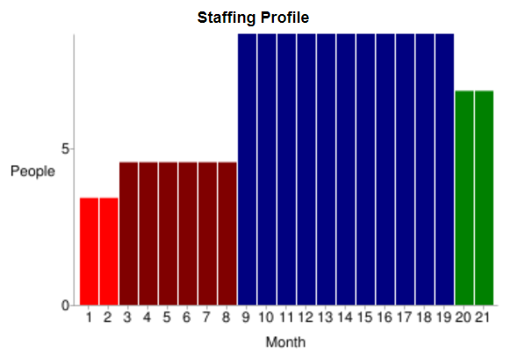

1. **A risk analysis outlining the major risks and strategies for mitigating the risks. You may base your risk analysis on the executive summary and the use cases that you used for cost and effort estimates.**

There are many major risks associated while developing a project. Some are small, and some are catastrophic which can me mitigated using some strategies. Some of the risks encountered are

**Estimation and scheduling**

Before starting, the project should be estimated the overall cost and time taken in development.

The deadlines has to be met in planned time and the budget should be in control.To mitigate it a well planned document is created.

**Requirements specification**

Wrong estimation and collection of requirement may lead to restarting the project.The things required for development of project should be estimated and collected before initiation.

**Technical issues** include:

**System interoperability:** Exchange of information should be done securely as it possesses a great threat when it is breached.

The strategy to mitigate is to make sure the data transfer is well maintained and secured.

**Call taking** : Due to heavy incoming calls there will be a risk of missing some of the emergency issues. Sometimes the call may be deviated or unanswered.

To mitigate this risk proper calling system is generated with huge servers and databases.

**Person information**: sometimes people with similar names make mess as service for one person may be deviated to another person.

To mitigate this risk, complete details about the person should be included along with their identification numbers.

**Modifying data:** Any entering, deleting or modifying of data inaccurately may lead to severe circumstances as the data will be mixed up with everything. To mitigate this risk, there should be a backup or history of all the data so whenever there is can issue, it can be reverted.

**Staff management**: sometimes staff may not be available for some tasks. This leads to halting the project which results in increase of cost and wastage of time. To mitigate this, extra staff have to be maintained so that they can be associated for the work.

**Delivery deadlines:** some time unable to deliver the project or unable to complete the specific tasks before the deadlines lead to problems. To mitigate this a well planned document has to be made so that the tasks are met with the schedule

**Fine-Grained Plan**

1. **A detailed process diagram for the first iteration of the Elaboration phase showing all of the activities with their inputs and outputs.**

This diagram shows how the first elaboration iteration might be planned. Even though this is a plan for a single iteration, not all Requirements and Analysis and Design work performed during this iteration is intended for Implementation and Test in this iteration.

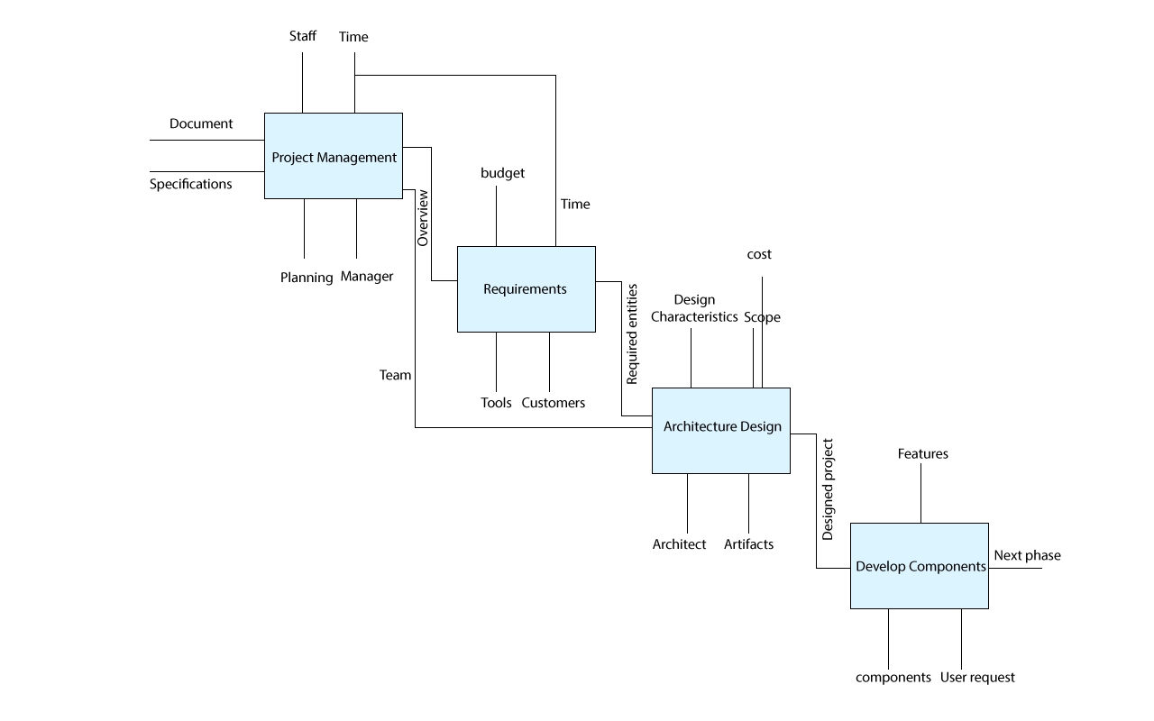

1. A Gantt chart showing the task dependencies, activity schedule, and delivery dates of all artifacts.

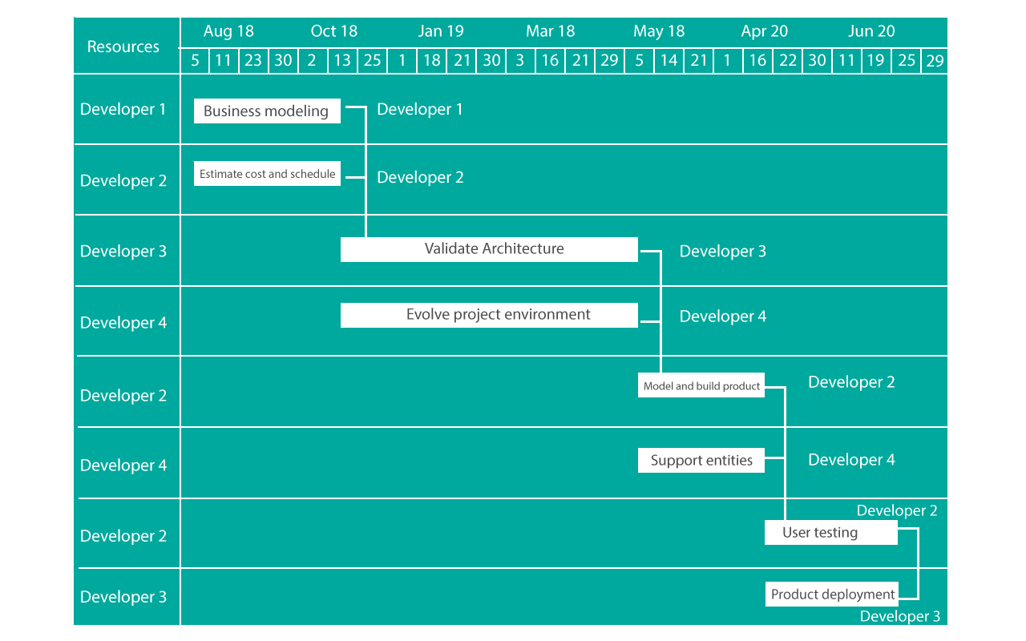

1. **A table showing how resources (e.g. developers) are allocated to tasks. You can refer to the members of the development team as Developer_1, Developer_2, etc. Make sure your table is consistent with the staffing profile of your course-grained plan.**

We create a table of 9 developers showing them taking different tasks to complete in different phases

|  |  |  |  |  |
| --- | --- | --- | --- | --- |
| Staff | Task | Phase | Effort | cost |
| Developer 1 | Planning & modelling, Quality assurance, build and develop, deployment | Inception, Transition, construction, elaboration | 130.1 | 1500 |
| Developer 2 | Budget and scope, build and develop, deployment | Inception, construction, transition | 130.1 | 1500 |
| Developer 3 | Effort and cost estimation, code design | Elaboration, construction | 130.1 | 1500 |
| Developer 4 | Analysis and design, code design, deployment | Elaboration, construction, transition | 130.1 | 1500 |
| Developer 5 | Build and develop, analysis and design | Construction, elaboration | 130.1 | 1500 |
| Developer 6 | Supporting documents, code design | Construction, inception | 130.1 | 1500 |
| Developer 7 | Quality assurance, code design, cost and effort estimation, deployment | Transition, construction, transition | 130.1 | 1500 |
| Developer 8 | Product testing, build and develop, deployment | Transition, construction | 130.1 | 1500 |
| Developer 9 | Deployment product, code and design, analysis and design, deployment | Transition, construction, elaboration | 130.1 | 1500 |